User Manual Tracker RPS v1.0

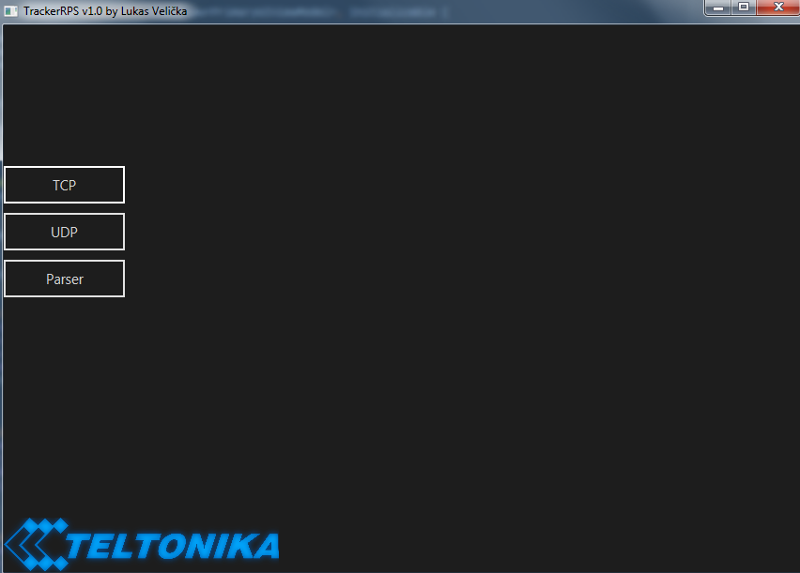
The marked area represents 3 buttons that opens in the main scene a view of selected button.
TCP – Opens TCP view scene.
UDP – Opens UDP view scene.
Parser – Opens Parser view scene.

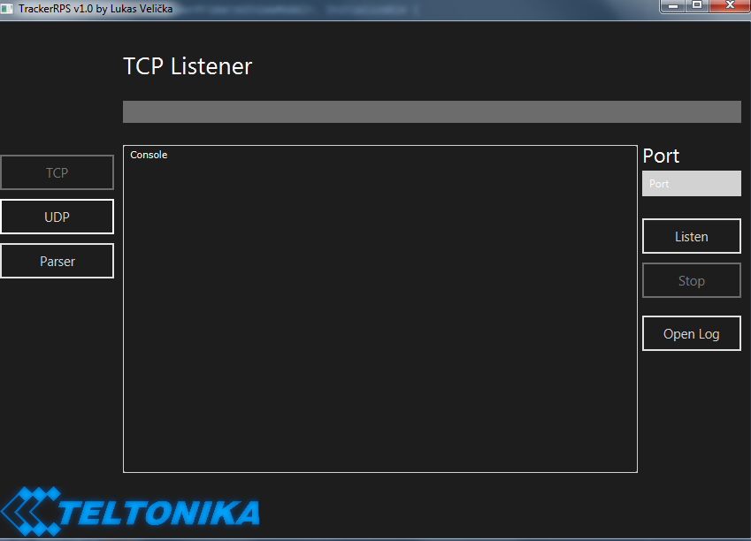
TCP Listener view
We can see the main console which is the output area, it displays all the results. On the right we see Port field for entering port, below buttons “Listen”, “Stop” and “Open Log”.

To Start listening enter port number, the TCP listener before starting listening will check if :
- Port entered is valid
- Is not in used
- Is reachable

If all conditions are met then the listener will start, and begin receiving data from clients. The log starts as soon as it receives its first data, all logs are stored by default location on desktop, Logs → TCP Logs → IMEI NUMBER. Txt. We can simply get to the logs folder by clicking on “Open Log”, it will open the folder of tcp logs. The TCP listener stores all logs in different text files by according to its imei.

When we want to stop listening simply press the “X” button or “Stop”. This will stop the listener and all its connections. Once its stopped we can change port or start all over again.

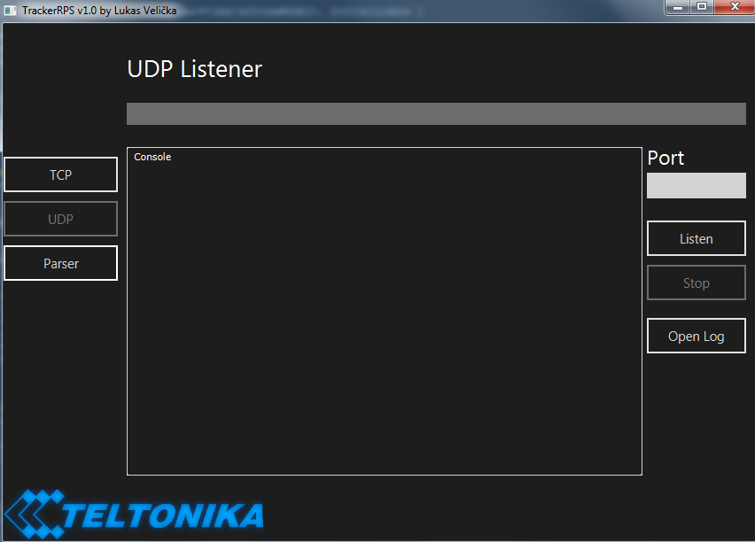
Similarly with TCP view, here we see same main console which is the output area, it displays all the results. On the right Port field for entering port, below buttons “Listen”, “Stop” and “Open Log”.

To Start listening enter port number, the UDP listener before starting listening will check if :
- Port entered is valid
- Is not in used
- Is reachable

If all conditions are met then the listener will start, and begin receiving packets from clients. The log starts as soon as it receives its first data, all logs are stored by default location on desktop, Logs → UDP Logs.txt We can open the UDP log text file by clicking on “Open Log”.

When we want to stop listening simply press the “X” button or “Stop”. This will stop the listener and all its connections. Once its stopped we can change port or start all over again.

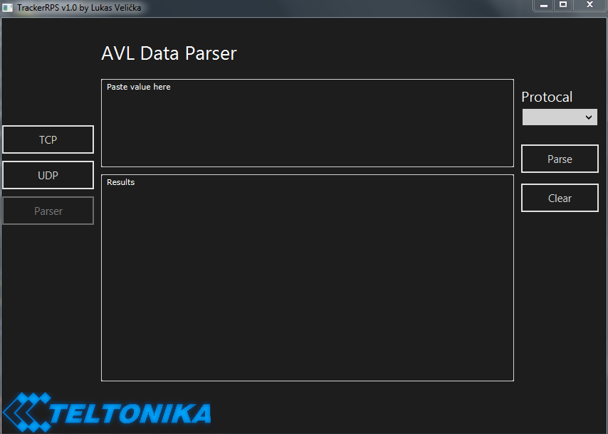
In the parser view we have two text area, in the upper the one that says “Paste value here”, we paste in the HEX data that we received from clients. The data will be found in log files.

To parse data from inserted value first we need to select Protocol :
- TCP – simply uses format to parse tcp type packet
- UDP – simply uses format to parse udp type packet
- Unknown – Purpose is only for try parsing raw data, it will read from codec 08 (if found) later on it will try parse the rest of data.

Once we inserted data and selected protocol we click on button “Parse”, the parsing process begins and the results will be displayed in the “Result” area. If we want to to parse another data, firstly it is recommended to clear the everything, to do this, press “Clear” button.

